Rain Water Harvesting Web
Group Member
- Umer Farooq
- Samiullah
- Umair Ali

Table of Content

- Acknowledgement page 2
- Software Requirement page 3
- Task Sheet page 4
- Problem Statement page 5
- Snapshots page 6

ACKNOWLEDGEMENT

I would like to acknowledge all those who have given me moral support and
helped in making the project a success.
I wish to express my gratitude to eProject Team at Head Office who guided
and helped me. Also, I would like to express my gratitude to all the staff
members of my centre for not only providing me opportunity to work with
them on this project, but also for their support and encouragement
throughout the process.
I also express my sincere gratitude to eProject Team from Aptech Head
Office and my project guide at the organization for his valuable guidance
and support for completion of this project.
Final, I would like to offer many thanks to all my colleagues for their
valuable suggestions and constructive feedback.

I would like to acknowledge all those who have given me moral support and helped in making the project a success.

I wish to express my gratitude to E-Project Team at Head Office who guided and helped me. Thanks To Our Faculty Sir Simon Anthony who Guided Us During The Project. Also, I would like to express my gratitude to all the staff members of my center for not only providing me opportunity to work with them on this project, but also for their support and encouragement throughout the process.

I also express my sincere gratitude to E-Project Team from Aptech Head Office and my project guide at the organization for his valuable guidance and support for completion of this project.

Final, I would like to offer many thanks to all my colleagues for their valuable suggestions and constructive feedback.

Thank You!

Hardware & Software Requirement

Hardware
- A minimum computer system that will help you access all the tools in the courses is a Pentium 166 or better
- 64 Megabytes of RAM or better

Software
- Notepad/HTML editor
- Dreamweaver
- IE 5.0/ Netscape 6.0

Task Sheet

S.NO | Task | Days spend | Working Members | Status
1 | Home | 6 | Umer Farooq
2 | Residential Area | 4 | Umer Farooq
3 | Commercial Area | 5 | Samiullah
4 | Information | 6 | Umair Ali
5 | About Us | 3 | Umer Farooq
6 | Contact us | 3 | Samiullah

Problem Statement

Rainwater harvesting is a technique used for collecting, storing and using rainwater for landscape irrigation and other uses. The rainwater is collected from various hard surfaces such as rooftops and/or other manmade aboveground hard surfaces. For a dry climate , rainwater harvesting can make a huge beneficial impact on the environment.
Most rural households have to source all their water on their property, and rainwater often provides a better quality household supply than river, bore or dam water. Rainwater harvesting is not just for rural areas though. Although urban households may be connected to a reticulated, treated (mains) water supply, rainwater harvesting can significantly lower mains water usage.
What are the benefits of rainwater harvesting? It will reduce water bills, provide an alternative supply during water restrictions and help maintain a green, healthy garden. In fact, depending upon tank size and climate, rainwater harvesting can reduce mains water use by 100%. Rainwater harvesting also decreases storm water runoff, thereby helping to reduce local flooding and scouring of creeks.
We are here looking at a website which will provide brief details about few facts and details about rainwater harvesting

The website is supposed to provide user friendly environment and navigation. The important menu must be stated in the top section of the webpage. Also a decent look out and color combination is expected.

The website is to be developed for the Windows Platform using HTML5, JavaScript and Geolocation. The site should work well in all leading browsers including Chrome, IE, Firefox etc.

Home Page
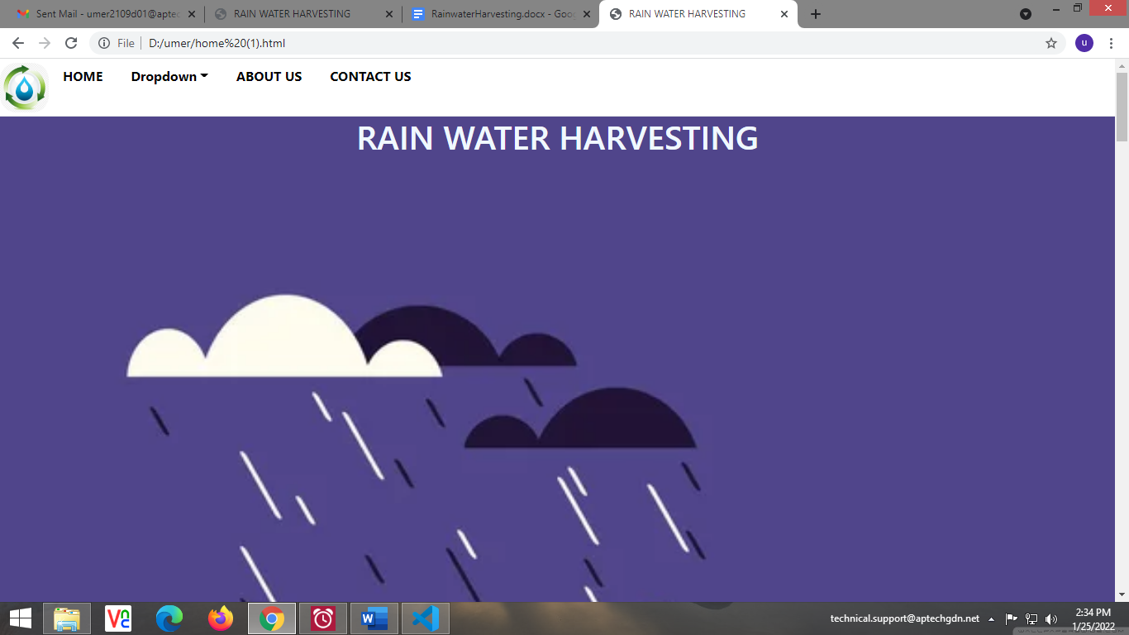

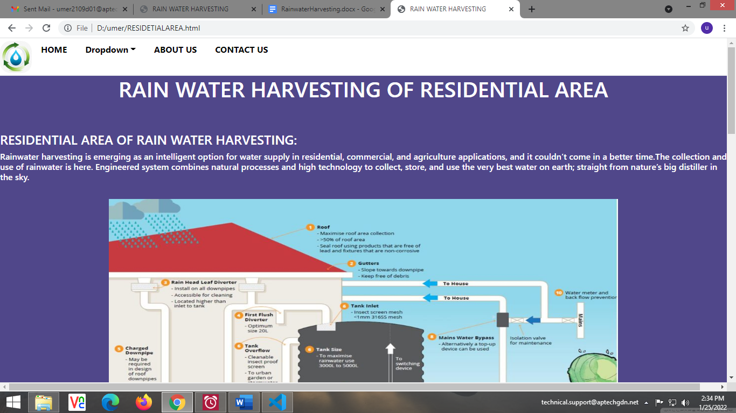
Residential Area

Commercial Area

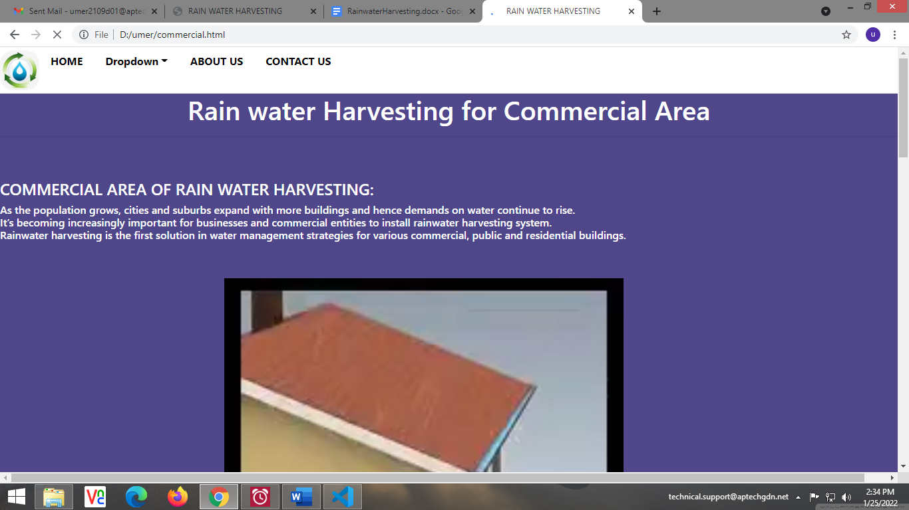

Information
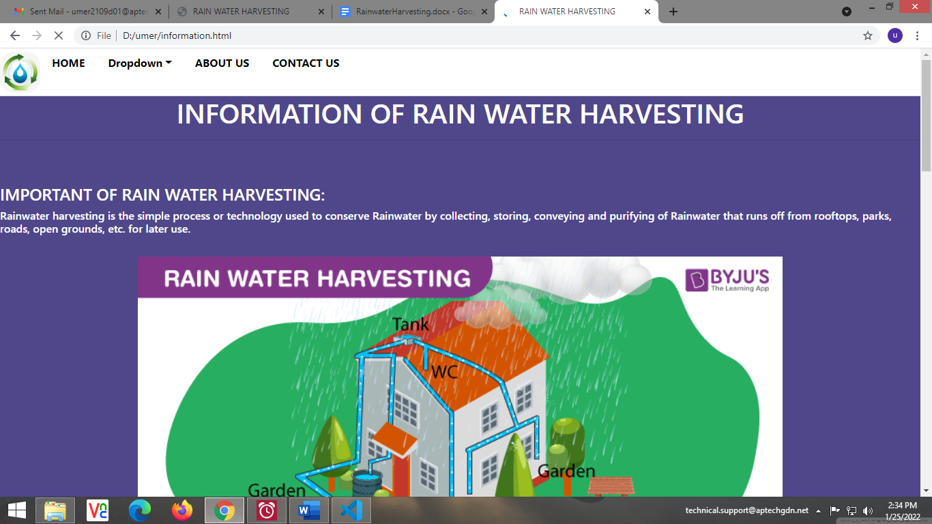

About Us
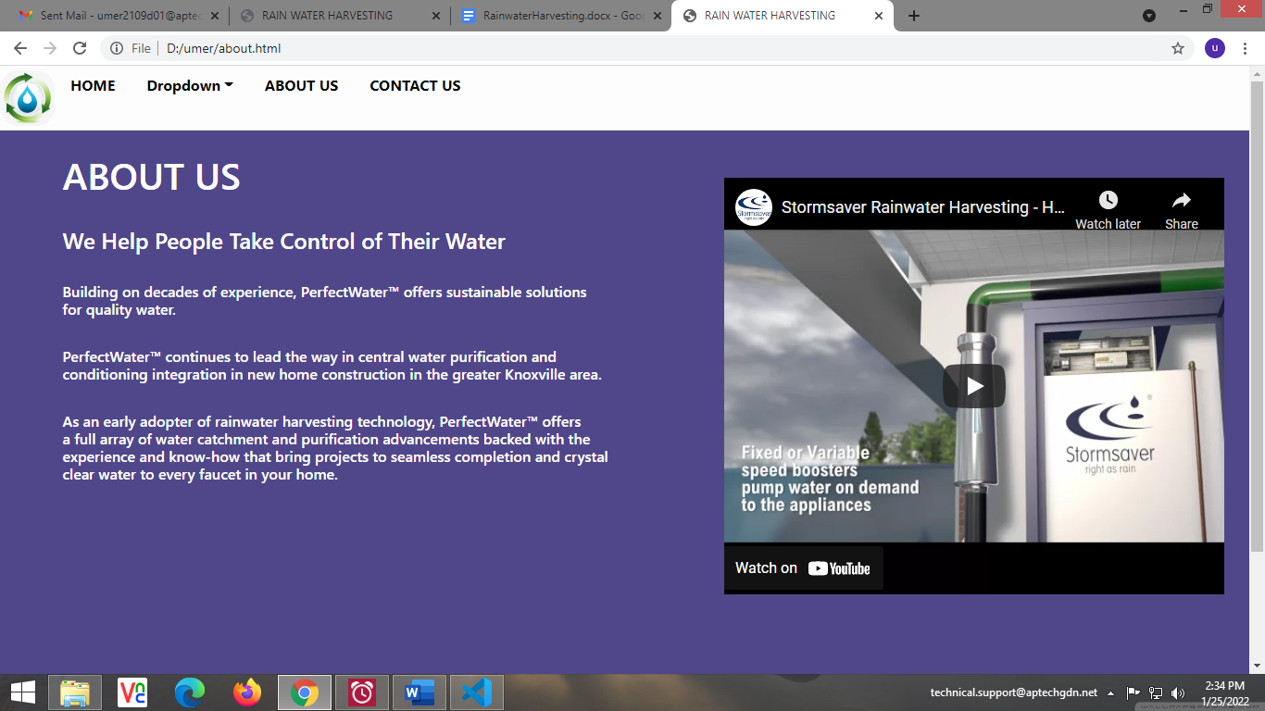

Contact Us
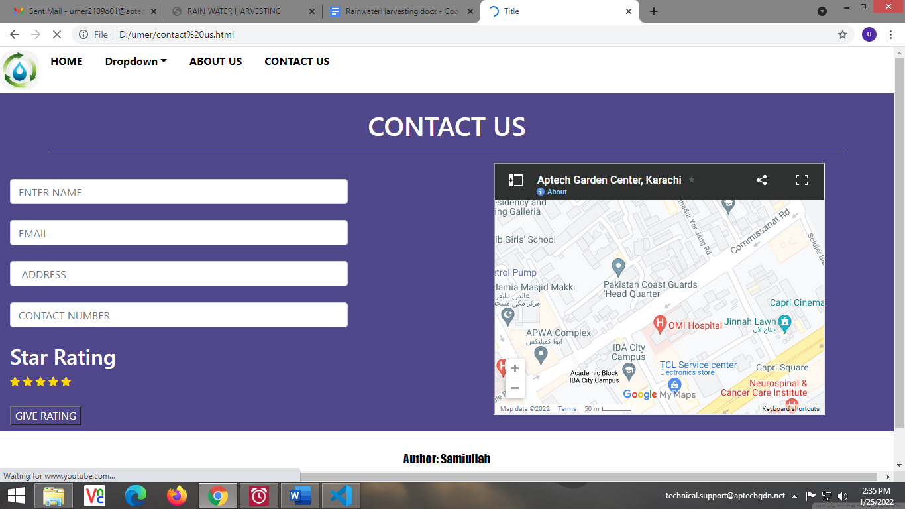

Thank You!

